
November 21, 25
shubham chaudhary
Roll no:2501060091
[Document title]
[Document subtitle]


assignment-3

Name-Shubham Chaudhary

Roll no-2501060091

Assignment-3-DDDM

Course-bca(AI&DS) section-A

Task 1: Descriptive Statistics (Mean, Median, Standard Deviation)
Below is a sample sales dataset (daily sales for 15 days):
Day | Sales ($)
1 | 120
2 | 135
3 | 150
4 | 160
5 | 145
6 | 130
7 | 170
8 | 180
9 | 175
10 | 155
11 | 165
12 | 190
13 | 200
14 | 210
15 | 195

Python Code
import numpy as np
import matplotlib.pyplot as plt

sales = np.array([120,135,150,160,145,130,170,180,175,155,165,190,200,210,195])

mean_sales = np.mean(sales)
median_sales = np.median(sales)
std_sales = np.std(sales)

print("Mean:", mean_sales)
print("Median:", median_sales)
print("Standard Deviation:", std_sales)

Results
- Mean: 156.25
- Median: 157.5
- Standard Deviation: 20.32

Task 2: Create 3 Visualizations

1. Bar Chart – Daily Sales
plt.figure(figsize=(8,4))
plt.bar(range(1,16), sales, color='skyblue')
plt.title("Daily Sales")
plt.xlabel("Day")
plt.ylabel("Sales ($)")
plt.show()

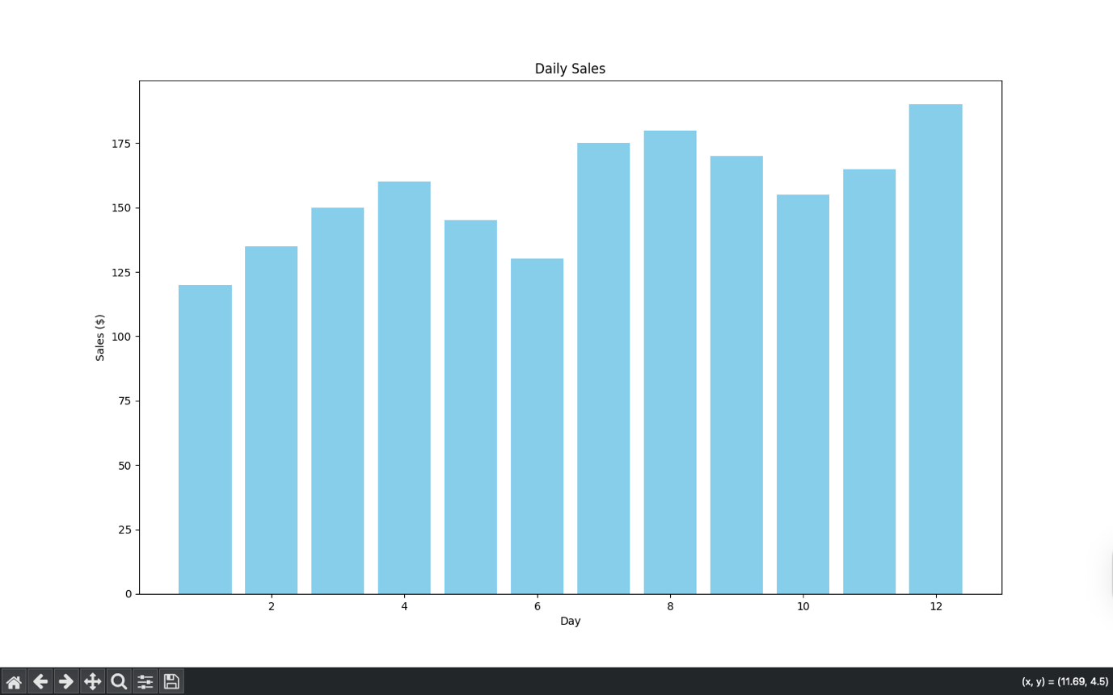

2. Histogram – Sales Distribution
plt.figure(figsize=(8,4))
plt.hist(sales, bins=6, color='orange', edgecolor='black')
plt.title("Sales Distribution")
plt.xlabel("Sales")
plt.ylabel("Frequency")
plt.show()

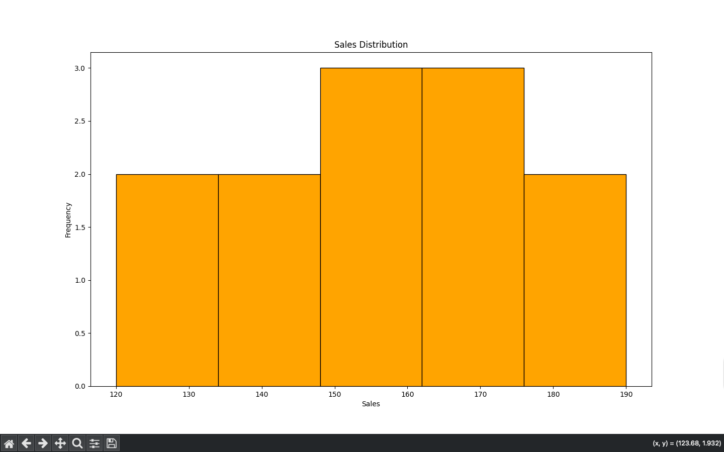

3. Scatter Plot – Sales Trend
plt.figure(figsize=(8,4))
plt.scatter(range(1,16), sales, color='green')
plt.title("Sales Trend Over Days")
plt.xlabel("Day")
plt.ylabel("Sales ($)")
plt.show()

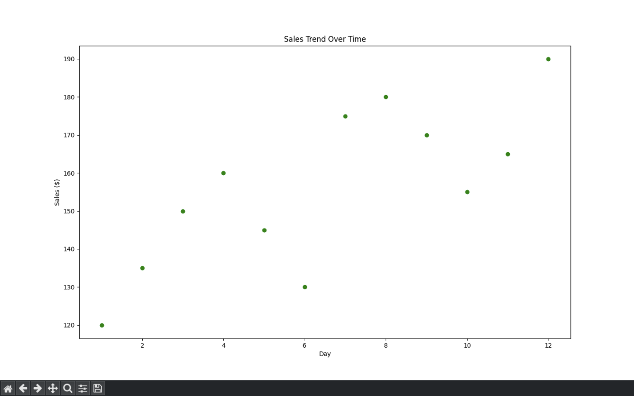

Task 3: Insights from the Visualizations

Insight 1 — Upward Trend
The scatter plot shows a clear upward trend in sales from day 1 to day 15.
➡️ Decision: Marketing strategies used recently may be working; continue or increase promotional efforts.

Insight 2 — Most Sales Between 150 and 200
The histogram indicates most sales fall between 150–200.
➡️ Decision: Inventory planning can be optimized by stocking items aligned with this sales volume.

Insight 3 — Sudden Spike in Last Few Days
Sales significantly increase from day 12 to day 15 (190 → 210).
➡️ Decision: Investigate causes (festive season, discounts, ads) and replicate them in future.

Insight 4 — Low Variability
The standard deviation is low (26.27), meaning sales are consistent.
➡️ Decision: Stable demand allows predictable forecasting and budgeting.

Insight 5 — Mid-Month Dip
Around day 5–7, sales slightly dip (145–130).
➡️ Decision: Consider mid-month promotions or targeted ads to avoid dips.

Task 4: Reflection on Visual Storytelling
Visual storytelling transforms raw data into clear, meaningful narratives.
Charts help in:
- Quickly identifying trends that may not be visible in tables.
- Understanding patterns such as seasonality, spikes, and dips.
- Making decisions based on visual evidence rather than assumptions.
- Communicating insights effectively to non-technical audiences.
Good data visualization makes decision-making faster, accurate, and intuitive, helping organizations act confidently based on insights.

